**MinIO Proof Of Concept**

MinIO is a High-Performance Object Storage released under GNU Affero General Public License v3.0. It is API compatible with Amazon S3 cloud storage service. It can handle unstructured data such as photos, videos, log files, backups, and container images with the maximum supported object size of 5TB.

Performed POC in 2 steps,

**Step – 1**

In this we try to connect MinIO system via Eclipse using below-mentioned code(project attached below) and library used.



Library:



Reference:

<https://min.io/docs/minio/linux/developers/java/API.html>

File has been created successfully with name “TESTPO1234.pdf”

**Step - 2**

After successful execution of Eclipse POC, used same as a reference and created relevant scenario in SAP PO.

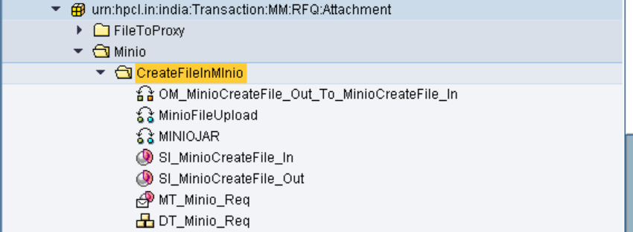

Created above design objects and below is Message request going to MinIO,

<soapenv:Envelope xmlns:soapenv="http://schemas.xmlsoap.org/soap/envelope/" xmlns:n0="urn:hpcl.in:india:Transaction:MM:RFQ:Attachment">

<soapenv:Header/>

<soapenv:Body>

<n0:MT_Minio_Req>

<!--Optional:-->

<RFQ>12345678</RFQ>

<!--Optional:-->

<Filename>12345678_01_test_0001.pdf</Filename>

<!--Optional:-->

<binarydata>?</binarydata>

</n0:MT_Minio_Req>

</soapenv:Body>

</soapenv:Envelope>

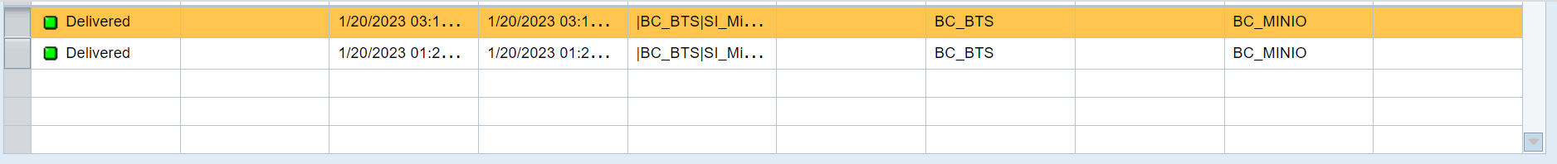

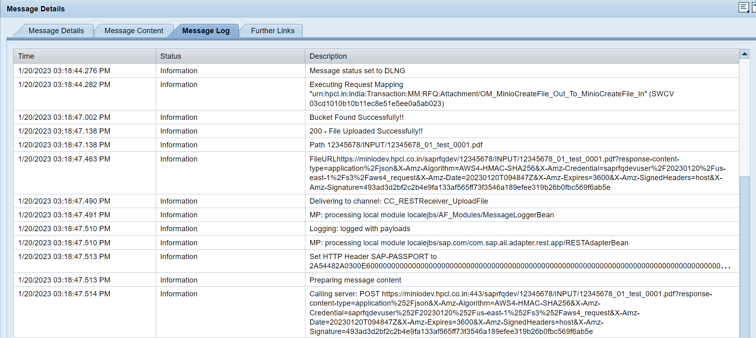

And successfully created relevant folder and file in MinIO.

